Curriculum and Instruction
Advanced Academic Services

1st Grade Science: Force, Motion and Energy

TEKS/Standards addressed: 1.6 (A) identify and discuss how different forms of energy such as light, heat, and sound are important to everyday life.

Thinking Skills | Depth and Complexity | Research Skills/Sources | Products/Performances
Judge with Criteria  Prove with Evidence  Ability to Relate  Solve or Resolve | - Language of the Discipline  - Details  - Rules  - Patterns  - Big Ideas  - Parallels | Verify  Draw Conclusions  Investigate  Guided Discovery  Infer | Light, Heat, Sound Organizer  Group Investigation Sheets  Peep Box  Sound Table  Energy Journal

Materials and Resources:

Kleenex Boxes Rubber Bands Penny
Prism Computers Hershey Bar
Mirrors Flashlight Headphones
Tin Foil Foam Plate Cardboard
Rubber Balls Ziploc Bags Teacher Pages
Colored Cellophane Glittery Cards Modeling Clay
Differentiation Chart:

Lesson Introduction:

Through a variety of activities, the students will observe and discuss how light travels in a straight line and is reflected by certain materials. They will also consider the effects of having no light. In addition, students will observe and investigate the effects of heat and the transference it has on an object. Students will categorize the different types of sounds while observing sound waves.

Definitions and examples: (Language of the Discipline)

Energy- ability to do work to move an object.
Light- energy source that keeps us warm and allows us to see the world.
Reflect- rays of light or heat that bounce off an object.
Bright- light or color that is strong and can be seen clearly.
Dark- without light
Heat- energy that comes from the motion of molecules passing from one substance to another, which increases temperature.
Transferred- heat energy is moved from one place to another.
Sound- something you hear.
Vibration- to move back and forth rapidly.
Sound Waves- a vibration of energy that travels through air or water.
High/Low Pitch- the level of a sound.
Soft- Quiet and gentle sound.
Loud- Noisy or a lot of sound.

Student Activities:

- INTRODUCTION TO FORCE, MOTION & ENERGY: Teacher will activate student prior knowledge and make predictions about sound, heat and light. Teacher will read Sound, Heat and Light: Energy at Work by Melvin Burger. Allow students time to review and identify 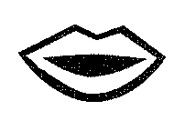 discuss their understanding and answer questions they may still have about the topic. Students will complete (R) “How I Use Light, Heat, and Sound” graphic organizer about how they use light, heat, and sound in their daily lives.

- HOW LIGHT TRAVELS: Teacher will distribute materials to students and allow them time to investigate, using a flashlight, how light travels in a straight line. For each activity students will illustrate 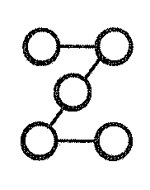 of light rays on (R) “How does Light Travel?”.

- LIGHT ACTIVITY: Teacher will allow students time and space to explore angles using bouncing balls. Students will observe the different angles at which the ball bounces. Once students have had a chance to bounce the ball to each other and observe, teacher can explain to them that light reflects off objects in a similar way. Students will draw 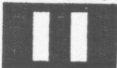 between the two actions, and record their observations of the activity on the (R) “Light Activity Sheet”.

- PEEP BOX: Teacher will review and discuss any questions students may have. Teacher will distribute materials to students and allow time to construct a Peep Box. Students will investigate the 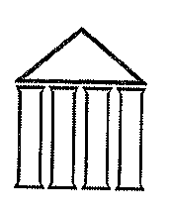 of their findings on (R)”Peep Box” student sheets.

- MELTING CHOCOLATE: Teacher will distribute materials. Students will analyze in heat transfer by experimenting with different types of materials. Students will record the results on (R) “Melting Chocolate” student page.

- ENERGY JOURNAL: Students will create a journal in which they can document their observations, investigations and student work. (R) “Student Journal Cover Page” will be stapled on top of student work or placed in a binder. Additional sheets of lined paper can be added to journal if needed.

FORCE, MOTION, AND ENERGY

Energy: You can think of energy as the ability to move or cause change in matter. Can you show me how you can move and create energy? What do you do on the weekend that needs energy? (ride a bike, clean house, cook, etc).

Light: Light is a very important energy source that keeps us warm and lets us see the world. Can you give an example of the Earth’s light source? Light travels in waves in bundles of energy called photons. Those photons contain all seven colors in the rainbow. Let’s grab a prism to check them out!

Heat: Heat is thermal energy. The faster an object’s particles move the more heat it has. Heat can be added to an object by making its particles speed up. Ask the students if they could create heat with their hands? How? What happens if we rub our hands faster?

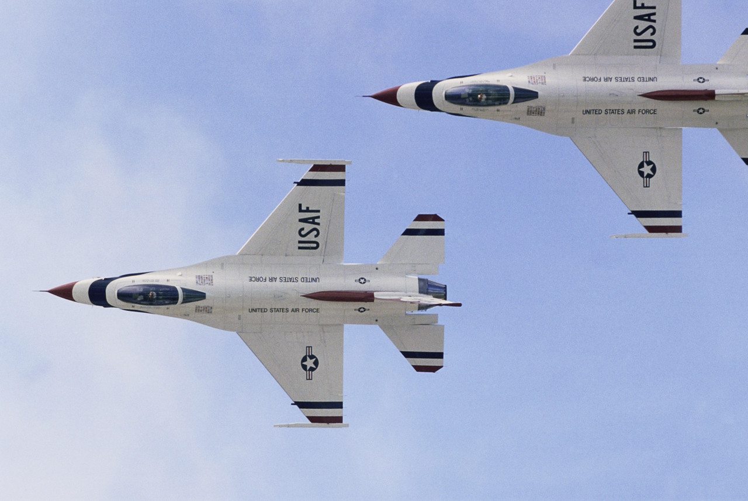
Sound: Sound is energy that travels as a result of vibration. With this Kleenex box and the rubber bands how can we make sound and vibration?
How I Use Light,Heat, and Sound

Date:___________________

I use light_______________________  _______________________________ | I use eat_________________________  ________________________________
I use sound________________________  _________________________________ | Name something that has light, heat, and sound.  ________________________________

(Teacher Copy)

Show that light travels in a straight line

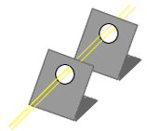
Bend 2 pieces of lightweight 8.5 x 11 poster board and cut a hole in exactly the same place in each one. Shine a flashlight through the holes to demonstrate how light travels in a straight line.
How does Light Travel?
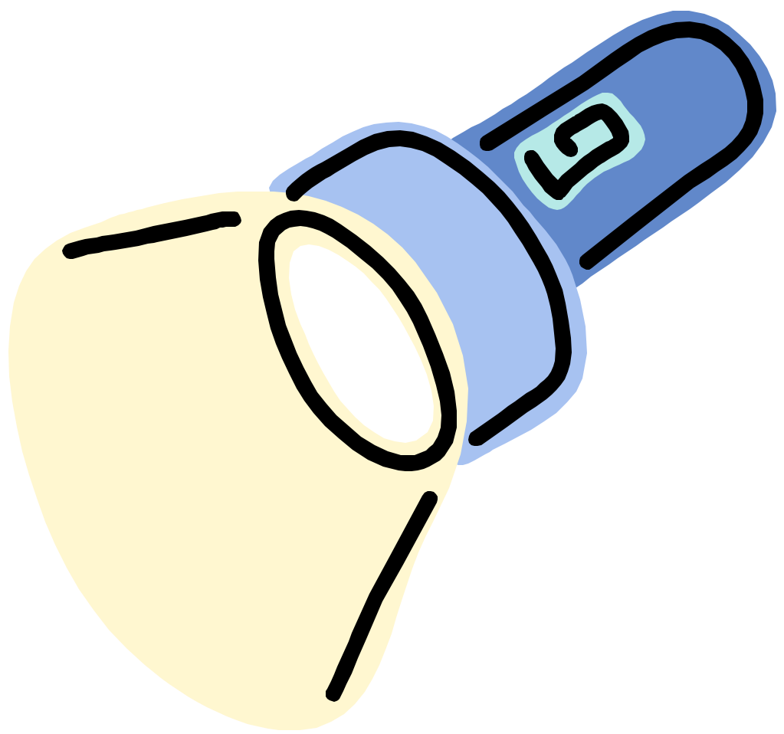
For each activity and result, the students will illustrate the of how light rays will travel.
How does Light Travel?
Experiment
Results

Date:________________________________

What will happen to the light, when the flashlight is turned on and we point it at the board?  The light will_____________________ | What were the results?  The light________________________
What will happen to the light if you put your hand in front of a hole?  The light will______________________ | What were the results? Were you correct?  The light________________________
Do you think you can block the light with mirror?  The light will___________________ | What happened?  The light____________

(Teacher Copy)

Objective:

Before playing with the flashlights, students will experiment with angles through the use of rubber balls.
Light Activity

Activity:

- Have your students discover for themselves that a bouncing ball’s incoming angel equals its outgoing angle. Ask your students to pair up, giving a ball to each pair.

- Have them bounce the ball back and forth (make sure the floor or pavement is smooth!) to each other. Ask them to share observations about the of how the ball bounces (observations will vary).

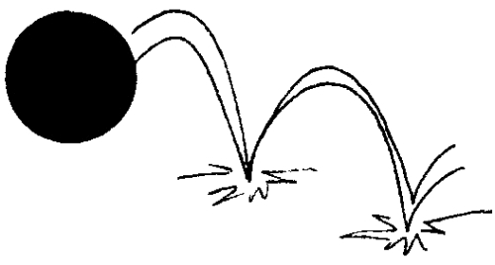
- If no one observed the angle at which a ball bounces, prompt the desired observation by asking students to throw the ball to each other from different angles. For instance, if they throw the ball straight down, will it bounce toward their partner? Or it will bounce straight up? If they push it down and away, they will create a gentler angle and the ball will reach their partner. Explain to them that light reflects off objects in a similar way.
Light Activity

(Teacher Copy)

Objective:
After rubber ball activity, students will identify between the angles created by the balls and those of the light from a flashlight on mirrors.

Activity:
Provide students with a small mirror and arrange your students’ desks in rows.

Create teams: rows 1 and 2 are a team, 3 and 4 are a team, and so on. Make sure that each student has a mirror.

Give a flashlight to the students sitting in the first desk of rows 1, 3, 5, and so on. Students without mirrors can be the flashlight holders.

Turn off the lights. Challenge the teams to adjust their mirrors so that the light from the flashlight reflects off everyone’s mirror on the team and reaches the last person in the row, as shown. Take note of the different created, and try to generate a set of from these.

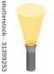
LIGHT ACTIVITY Row 2
Light Activity

Row 1

Questions that follow activity should be discussed orally. Teacher can record the answer for the student.

Date:_________________________

How can we illustrate our results?

What happened to the light when it hit a mirror?______________________________
__________________________________________________________________

How did you get your light to bend?________________________________________
__________________________________________________________________

(Teacher Copy)

Make a peep box to show that we need light to see things

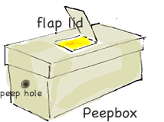
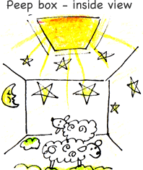
- Cut a small hole in the front of a shoe box and a square opening that can open and shut on the top of the lid. Line the opening with brightly colored cellophane.
Peep Box
2. Cut up images from glittery Christmas cards and stand them up inside with modeling clay to create a scene.
3. Have the children look inside with the square opening on the lid closed. Ask them what they can see. If the hole is shut securely on the lid they will probably say, "Nothing". Open the opening on the lid and again ask them to describe what they can see. Let the children play with the box and try shining a flashlight through the top hole. Discuss the they identify and try to generate some for light.

Date:_________________________

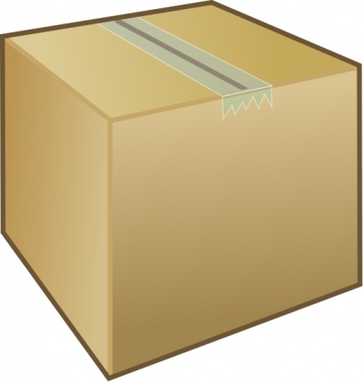
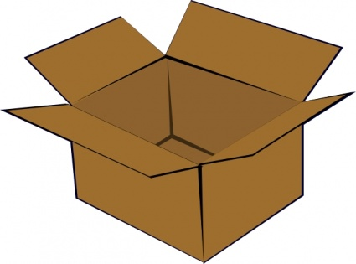
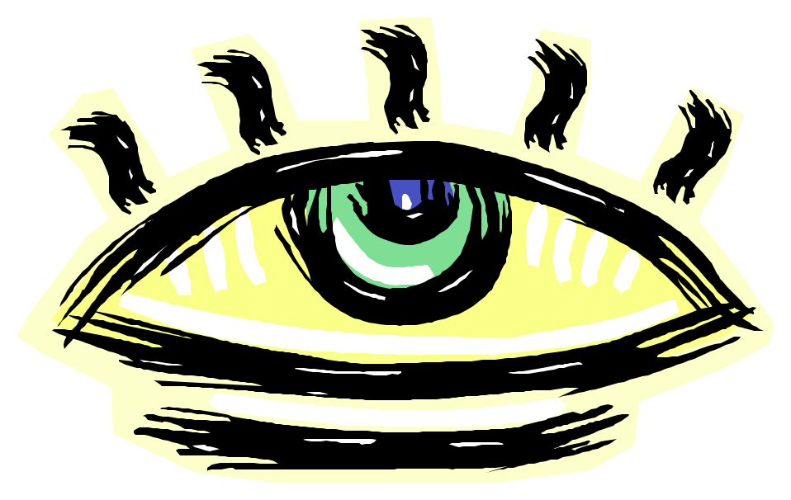
Peep Box
What do you think you will see?
(flap closed)
What did you see?
(flap closed)
What do you think you will see?
(flap open)
What did you see?
(flap open)

What did you see when the flap was closed?
_______________________________________________________________________________________________________________________________________________________________

Why?
_______________________________________________________________________________________________________________________________________________________________
Peep Box

What did you see when the flap was open?
_______________________________________________________________________________________________________________________________________________________________

Why?
_______________________________________________________________________________________________________________________________________________________________

Why is light important?
_______________________________________________________________________________________________________________________________________________________________

(Teacher Copy)

What you'll need:
- Small chocolate pieces of the same size (chocolate bar squares)
- Paper plates, tin foil, cardboard
- Pen and paper to record your results
Instructions:
- Put one piece of chocolate on a foam plate, another on the tin foil, and the last piece on cardboard. Put it outside in the sun.
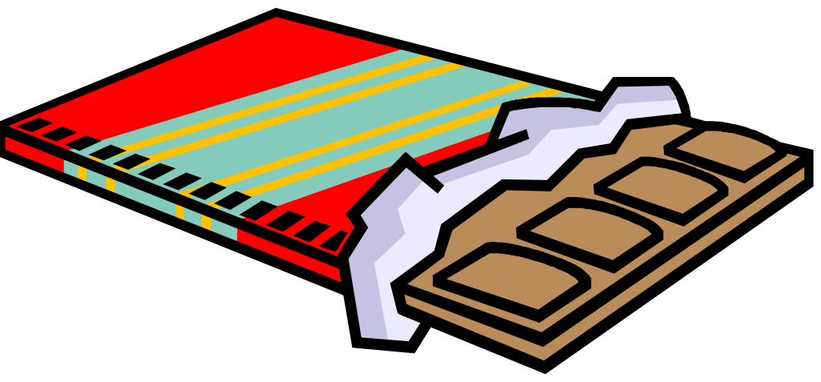
- Record how long it took for the chocolate to melt or if it wasn't hot enough to melt then record how soft it was after 10 minutes.
Melting chocolate
- Identify between results: which material transferred the most heat onto the chocolate? How do you know? Justify.
What's happening?
At a certain temperature your chocolate pieces undergo a physical change, from a solid to a liquid (or somewhere in between). On a hot day, sunlight is usually enough to melt chocolate, something you might have unfortunately already experienced.

Date:_______________________________

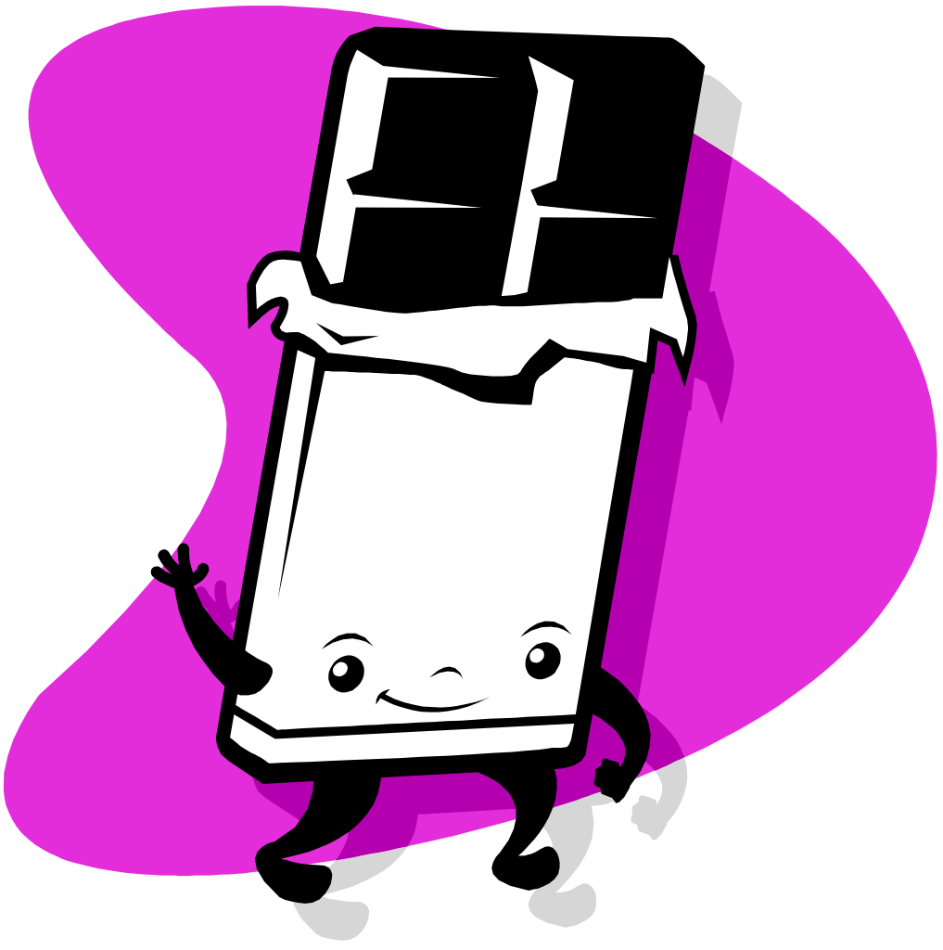
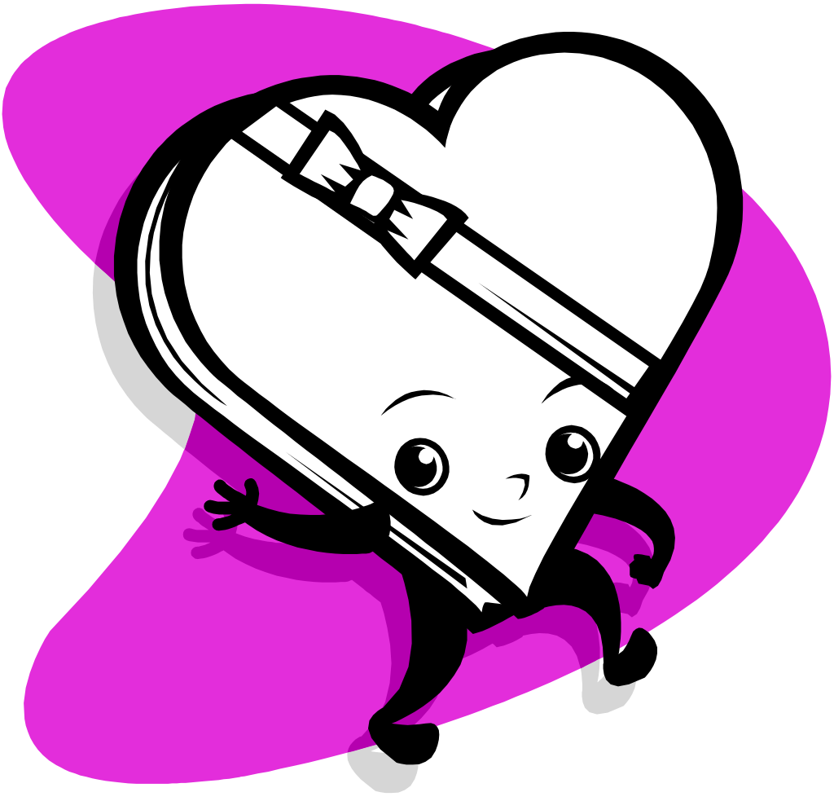
Melting chocolate
Foil
Foam Plate
Cardboard
Draw the results

What do you hear?

 | High Pitch | Low Pitch | Loud | Soft


