Curriculum and Instruction
Advanced Academic Services

2nd Grade Science: Organisms & Environments

TEKS/Standards addressed:
2.10 (A) observe, record, and compare how the physical characteristics and behaviors of animals help them meet their basic needs such as fins help fish move and balance in the water

Thinking Skills | Depth and Complexity | Research Skills/Sources | Products/Performances
Ability to Relate  Redesign  Solve or Resolve | - Language of the Discipline  - Details  - Rules  - Patterns  Relationships | Draw Conclusions  Investigate  Guided Discovery  Infer | Flow Chart  Video Notes  Tadpole Diary  Clay Model  Skit  Picture Time Line

Materials and Resources: (list)

Frog Anticipatory Set internet
Differentiation Chart:
From Tadpole to Frog by Wendy Pfeffer Glue, tape
Crayons, markers, pencils Tadpoles, food, aquarium with lid (SRC)
Modeling Clay (different colors) Green paper plates
Yarn Scissors
Googly Eyes Butcher Paper
Pictures of students as babies, toddlers, and present

Videos:
Animal Life Cycles (section on amphibians)
Animal Groups: Beginning Classification (section on amphibians)
Life Cycle of a Frog
"Metamorphosis (Tadpole Into a Frog)" by Lucas Miller, YouTube Video

Websites:
Frog Life Cycle

Lesson Introduction:
If possible, teacher may get a set of live tadpoles for the class. Students will investigate, observe and record the unique stages of the life cycle of a frog. Students will create a model of a frog’s life cycle and create a skit in which they explain how the developments affect the tadpole’s ability to survive. Students will also find  in the life cycle of a frog and in their own growth 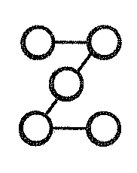. Then they will predict how their own physical characteristics will change and how they will look as an adult.

Definitions and examples: (Language of the Discipline):

Metamorphosis- a major change in form from one stage to the next
Tadpole- the larval stage of metamorphosis of a frog
Frog- the adult stage of metamorphosis
Amphibian- (means two-lives) they spend their lives in water and on land
Spawning – release or deposit eggs
Limb – an arm or leg of human, or of a four-legged animal

Student Activities:

- INTRODUCTION TO LIFE CYCLE OF FROGS: Teacher will lead a class discussion on metamorphosis and the life cycle of frogs using (TR) “Frog Facts” and (TR) “The Life Cycle of the Common Frog.” Students will read the book From Tadpole to Frog, then create an original flow chart to illustrate the stages of a tadpole. Teacher may show video from United Streaming and have students write notes as they watch the video.

- DIARY OF A TADPOLE: Students will keep a Diary of a Tadpole written in the perspective of a frog. (TR) “Diary of a Tadplole.” As the students notice the changes, they will document the  in their diaries. (TR) “Day by Day Frog Development”

- FROG MODEL: Students will create the of the frog life cycle using modeling clay. This activity can be done in conjunction with the diary writing. As the students notice a change in the tadpoles, teacher will ask students to observe the physical characteristics and behaviors that help the tadpoles survive in their environment. How do these characteristics help meet their basic needs? What specific element defines each stage?

- FROG ACTING: Teacher will ask students to consider how each stage in the cycle  to the development of a frog. Students will then consider how the entire process would be affected if a single step is removed. As a group, students will create a short skit that demonstrates or predicts how this would affect an adult frog trying to interact with its environment.

- MY LIFE CYCLE: Teacher will ask students to remember about their life as a baby, and have them compare this stage to those of a frog. Ask students to bring in photographs of themselves as an infant, toddler, and a current picture to evaluate their changes . Have students create a “life cycle” using pictures. Students will envision and create a drawing of them in the future. Students will find between their life and that of frog (R) “Frog Life .” If time permits, students may prepare a presentation.

Frog Facts

- The word amphibian means two-lives. Amphibians spend their lives in the water and on land.

- Frogs, Toads, Salamanders and newts are all considered amphibians.

- Skin is porous and moist and assists in their breathing.

- Can emit sounds by expelling air from their lungs.


- Does not drink water but rather absorbs moisture through their skin.

- Are cold blooded.

- Stages 1-4: egg, tadpole, froglet, adult frog

- Most frogs have webbed feet to help them swim and move in the water.

- Frogs have very strong back legs which makes hopping easier.

- Frogs catch their food with their long sticky tongue.

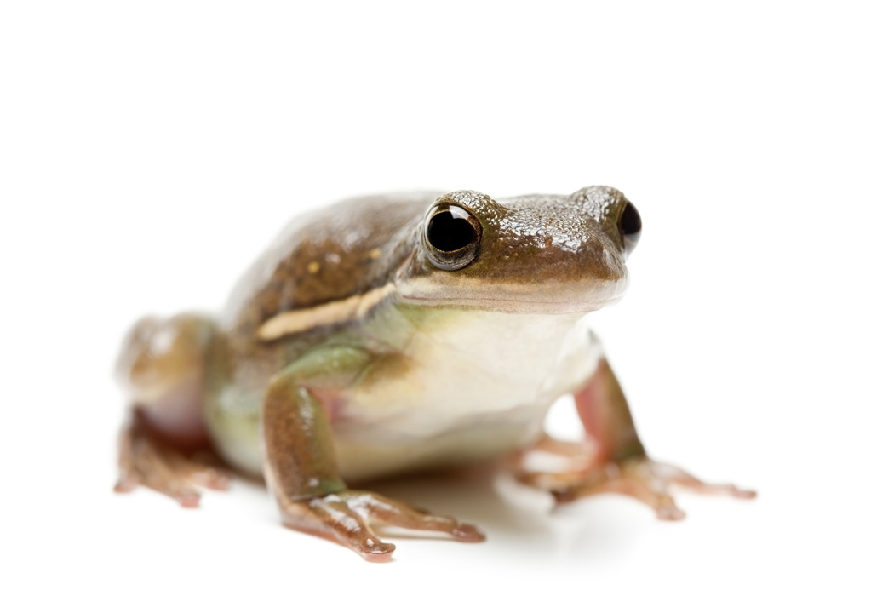
- Their eyes and nostrils are on top of their head so they can see and breathe while most of their body is under the water.

THE LIFE CYCLE OF A COMMON FROG
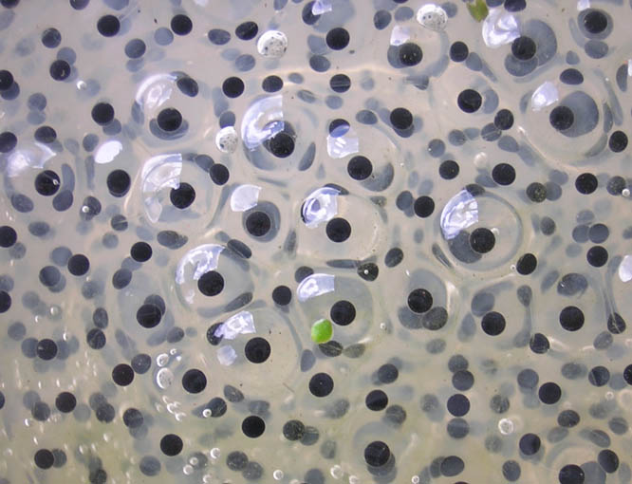
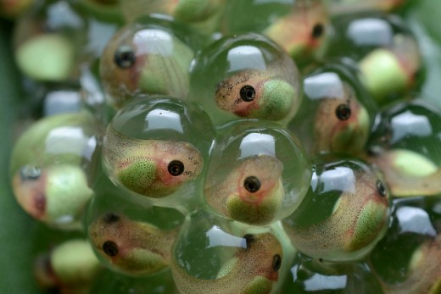
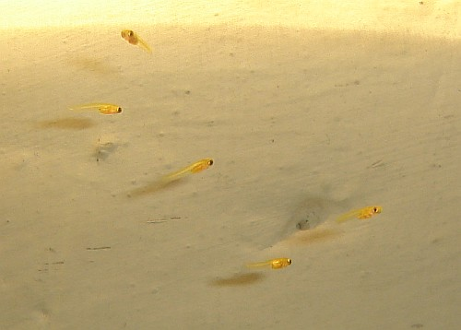
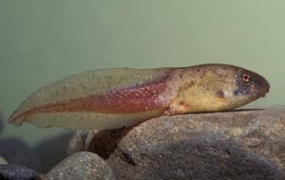
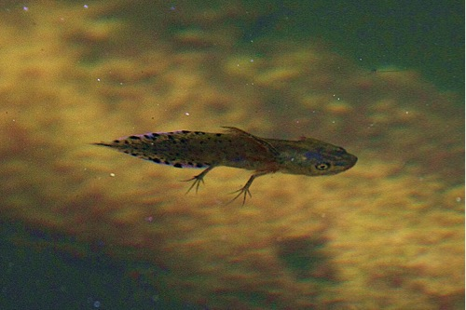
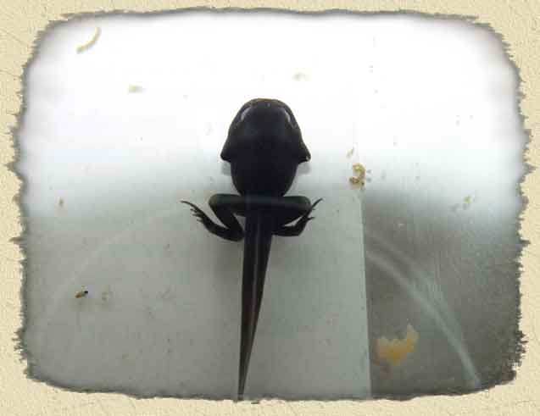
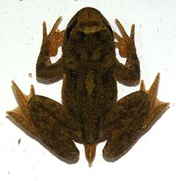
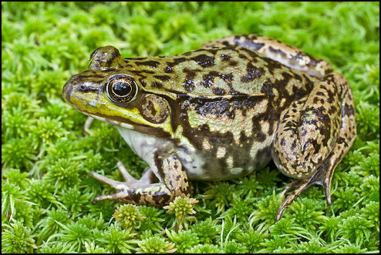
w
frogspan (eggs)
Tadpoles developing in the eggs
one day old
four weeks old
six weeks old
nine weeks old
12 weeks old
over one year old
Day by Day Frog Development

Day 1:
- Spawning – Female frog releases thousands of eggs into the water so that male frog can fertilize the eggs. Once the eggs are fertilized, the male will leave and sometimes so will the female. Only a few of eggs will survive, some eggs get broken by water and others will get eaten by small animals.

Days 7-9:
- The eggs that survived will start hatching and begin life as tadpoles, they will eat the egg yolk that is still left in its gut.
- Baby tadpoles have gills, a tail and a mouth

Week 4:
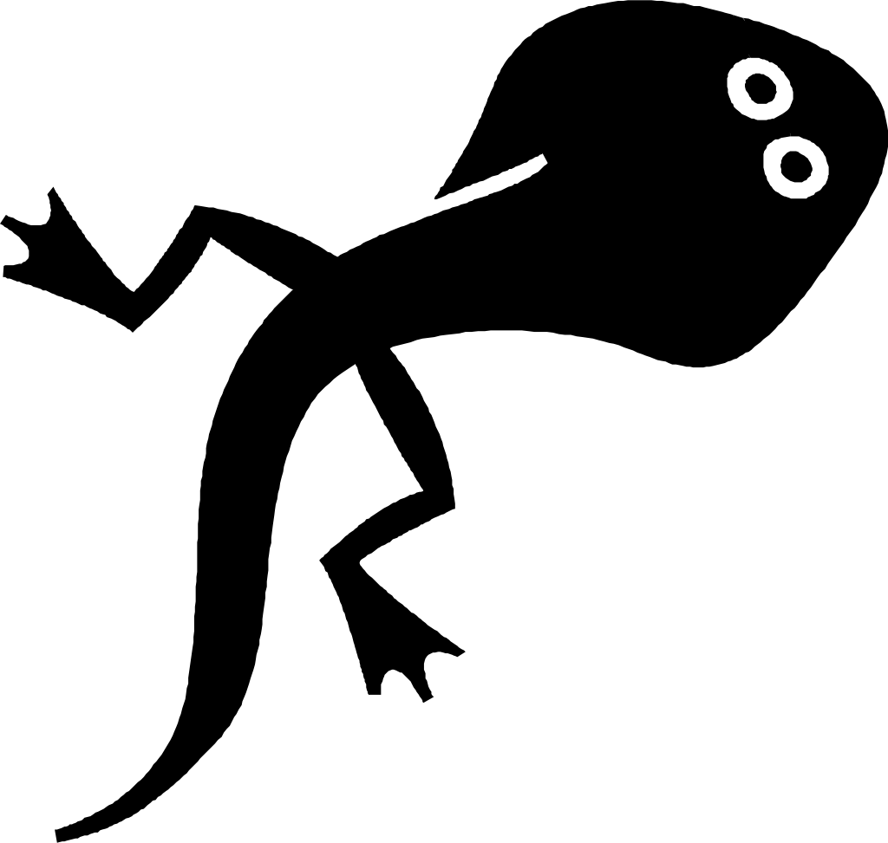
- Tadpoles will grow teeth, and skin over the gills. They will also become social and swim in schools

Weeks 6-9:
- Tadpoles grow longer and develop a little head and some legs
- Front limbs form at the same time as the rear limbs, but they form inside the body and are invisible until the metamorphosis is complete

End of week 9:
- At this point, the tadpoles begin to start eating tiny insects

Weeks 9-12:
- Tadpoles become froglets, they begin to look more like a frog however it still has a long tail
- Froglets will grow a tongue and lose most of its tail

Week 16:
- Frog is fully developed and becomes an adult frog

DIARY OF A TADPOLE

Ask students to think in the 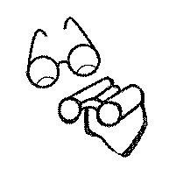 of a frog. If it could talk, what would it say or how would it feel during the stages of metamorphosis? Have students start writing a diary in the perspective of a frog, explaining the stages in detail. They need to give the frog a personality. Is the frog always happy, is it scared, timid, or brave? Teacher may have the students create their own diary, or prepare some simple books.

EXAMPLE:

Day 1
Dear Diary,
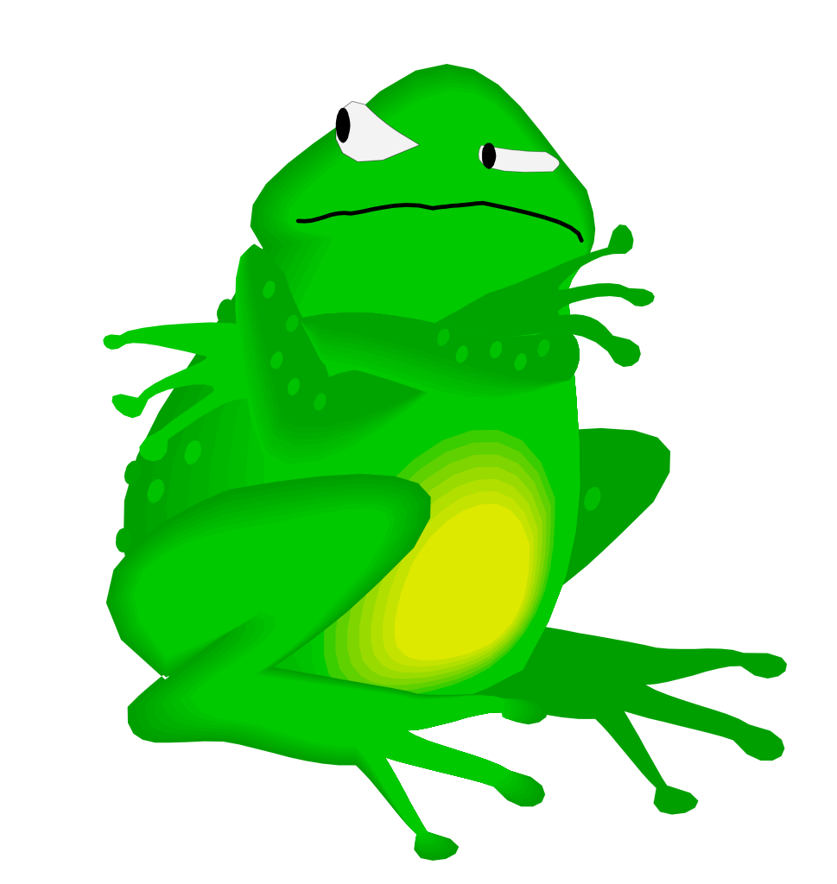
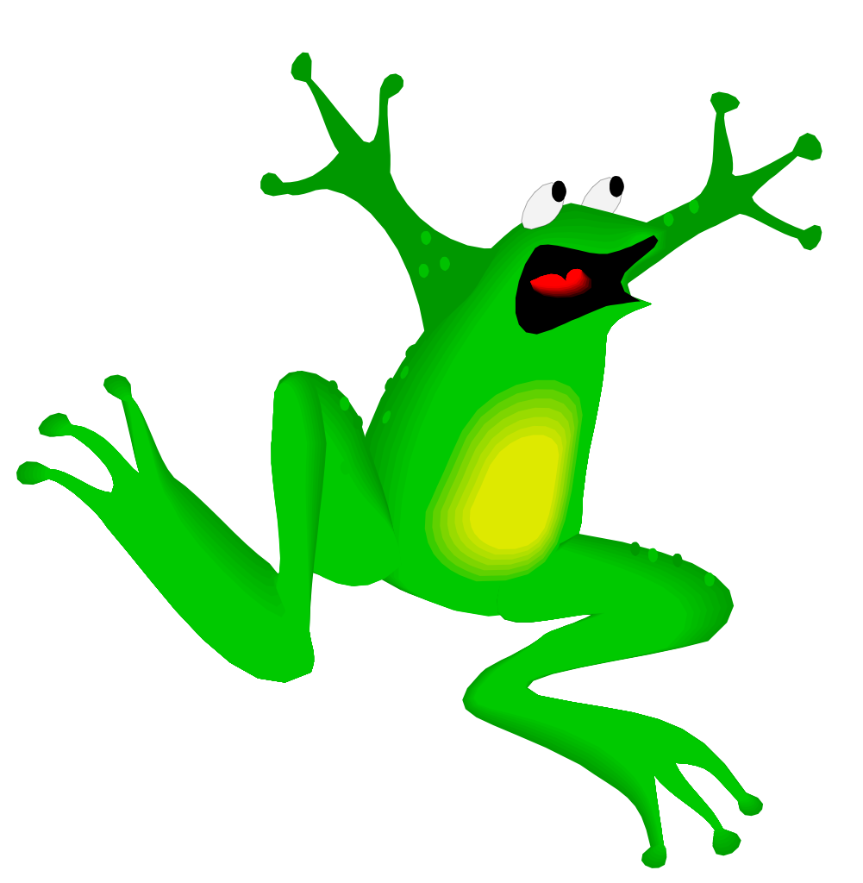
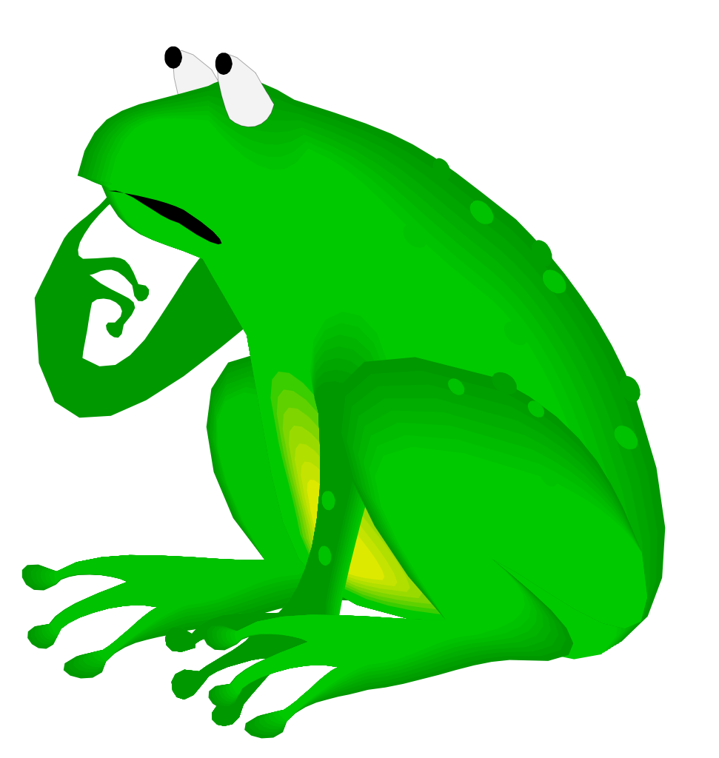

Today is going to be my birthday! It will be my first day in the water. I’m so excited to start swimming and jumping on all of the lily pads. Here we go, mom is pushing all of us into the water. Wow! I have thousands of brothers and sisters and we all look the same. Oh no….What happened? We’re not frogs, we’re just little black dots? Then one of my sisters told me that we are still eggs. Phew…I thought.

Frog Life

